**Linear Equations in Two Variables**

1. An equation of the form *ax + by + c* = 0, where *a, b* and *c* are real numbers, such that *a* and *b* are not both zero, is called a **linear equation in two variables**.
2. Linear equations in one variable, of the type *ax* + *b* = 0, can also expressed as a linear equation in two variables. Since, *ax* + *b* = 0  *ax* + 0.*y* + *b* = 0.
3. A **solution** of a linear equation in two variables is a pair of values, one for *x* and one for *y*, which satisfy the equation.
4. The solution of a linear equation is not affected when
   1. The same number is added or subtracted from both the sides of an equation.
   2. Multiplying or dividing both the sides of the equation by the same non-zero number.
5. A linear equation in two variables has **infinitely many solutions**.
6. Every point on the line satisfies the equation of the line and every solution of the equation is a point on the line.
7. A linear equation in two variables is represented geometrically by a straight line whose points make up the collection of solutions of the equation. This is called the **graph** of the linear equation.
8. *x* = 0 is the equation of the *y*-axis and *y* = 0 is the equation of the *x*-axis.
9. The graph of ***x = k*** is a straight line parallel to the *y*-axis. For example, the graph of the equation *x* = 5 is as follows:

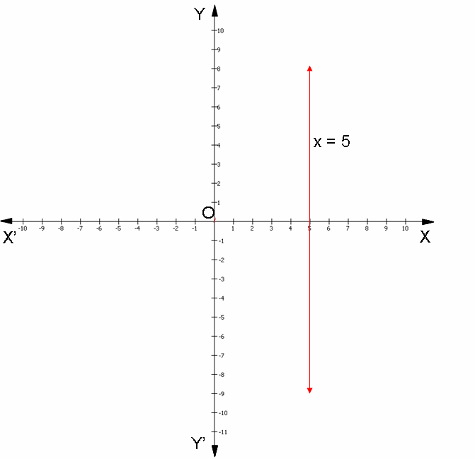

1. The graph of ***y = k*** is a straight line parallel to the *x*-axis. For example, the graph of the equation *y* = 5 is as follows:

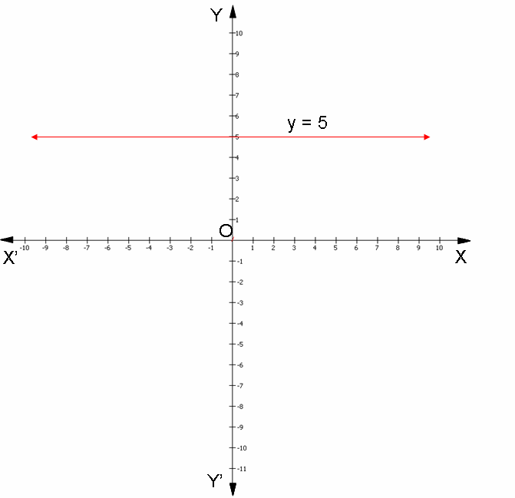

1. An equation of the type ***y = mx*** represents a line passing through the origin, where *m* is a real number. For example, the graph of the equation *y* = 2*x* is as follows:

